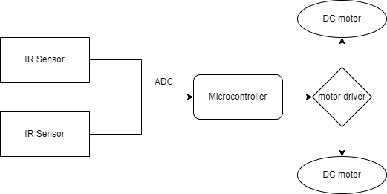

The above block diagram is of Line Follower Robot. In this project IR sensor is used to sense the line through which the robot can move. It gives either analog or digital output. It gives signal to microcontroller. Dc motor works as an actuator.